**Lab 11.1 - Prepare and Visual Recipes with Dataiku DSS**

# Part 1 - Go to Google Cloud

First go to <https://cloud.google.com/> and click go to console.

Each account can have $300 free credit trial, you’d better apply for the $300 credit free trial before start. If you once have an account and the free trail has already ended, you can apply another account with a new email address to get another $300 credit.

Step 1: Start the instance

Open the [Dataiku DSS](https://console.cloud.google.com/marketplace/details/dataiku-public/dataiku) page on Google Cloud marketplace

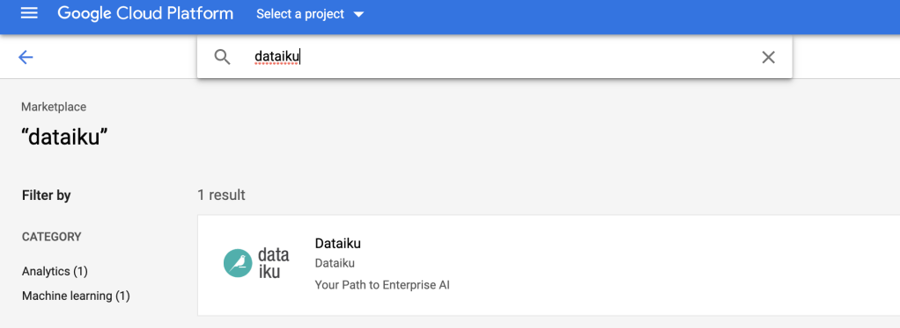

* Click **“Launch on compute engine”**. You will be invited to select the google projects you want to use.

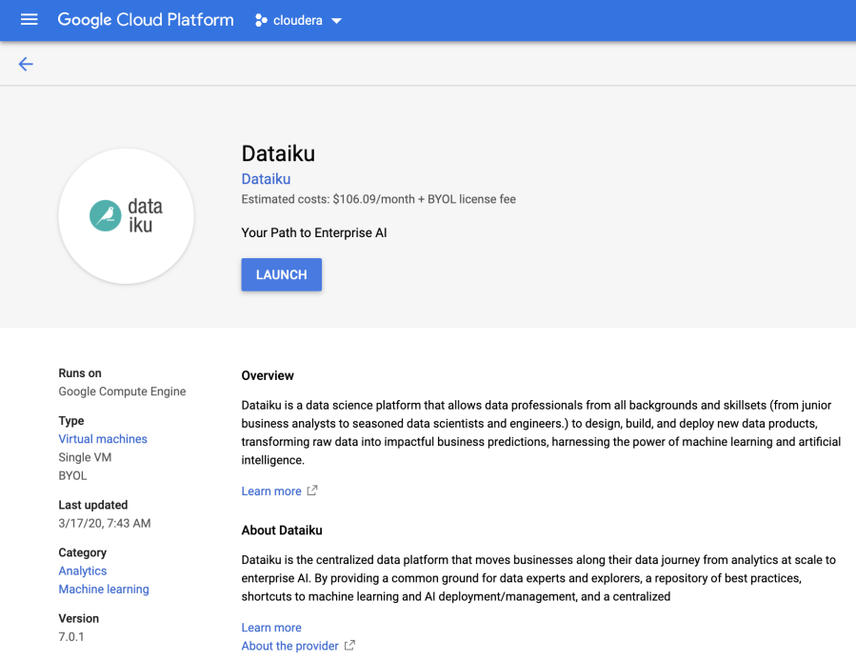

* Select one and click on **Open**
* Enter a name for your Virtual machine in the **“Deployment name”** section and select your region (if not the default) and disk size (at least 50 GB). For example, I selected us-east1-b because I am in NY, therefore the eastern region.
* Make sure you have firewall rules to access the application. Usually, it is pre-determined as follow and you do not have to change anything:

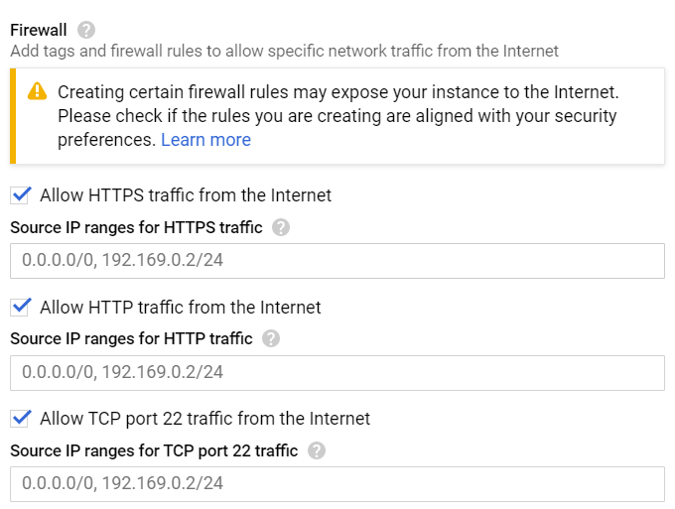

* A machine with 2 vCPUs, 16 GB RAM should be enough for a first test.
* Review the form and then click on **Deploy**.  
  (You may have one warning about the disk size being greater, but it’s expected)

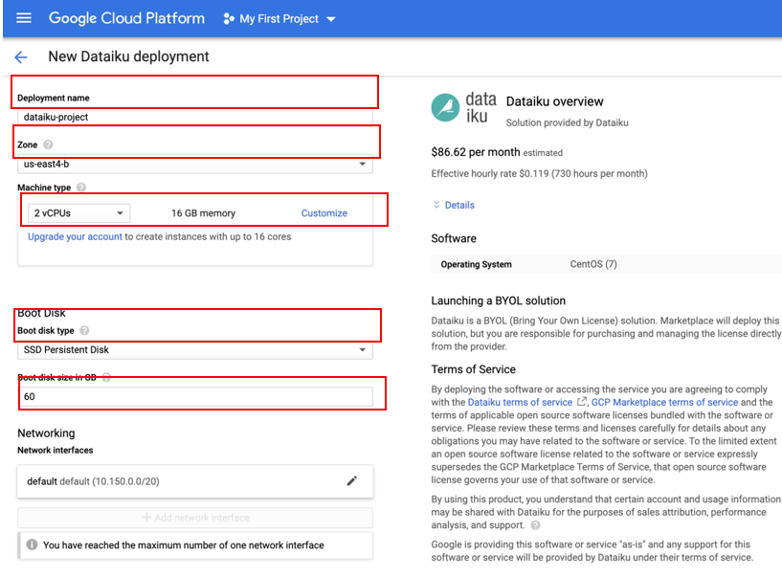

**Step 2: Connect to DSS**

Once deployed, in the Dataiku-Dss-Design section you might see a Site address, **Admin user and Admin password(remember this, you will have to enter them later)**. They are dedicated to the initial authentication on the web UI.

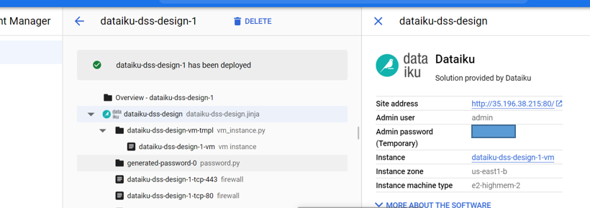

Click on the link in the **Site address** section. Then enter the username and password.

Please note that this is a one-time password only, and after logging in and registering DataIku will give you a different password.

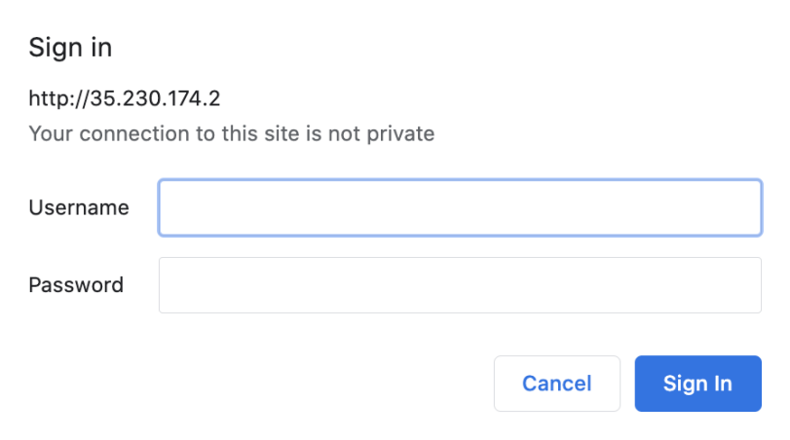

Then you will see this welcome page. Click No to create you Dataiku DSS license.

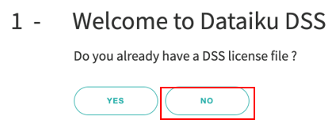

Then choose the free edition and fill your information.

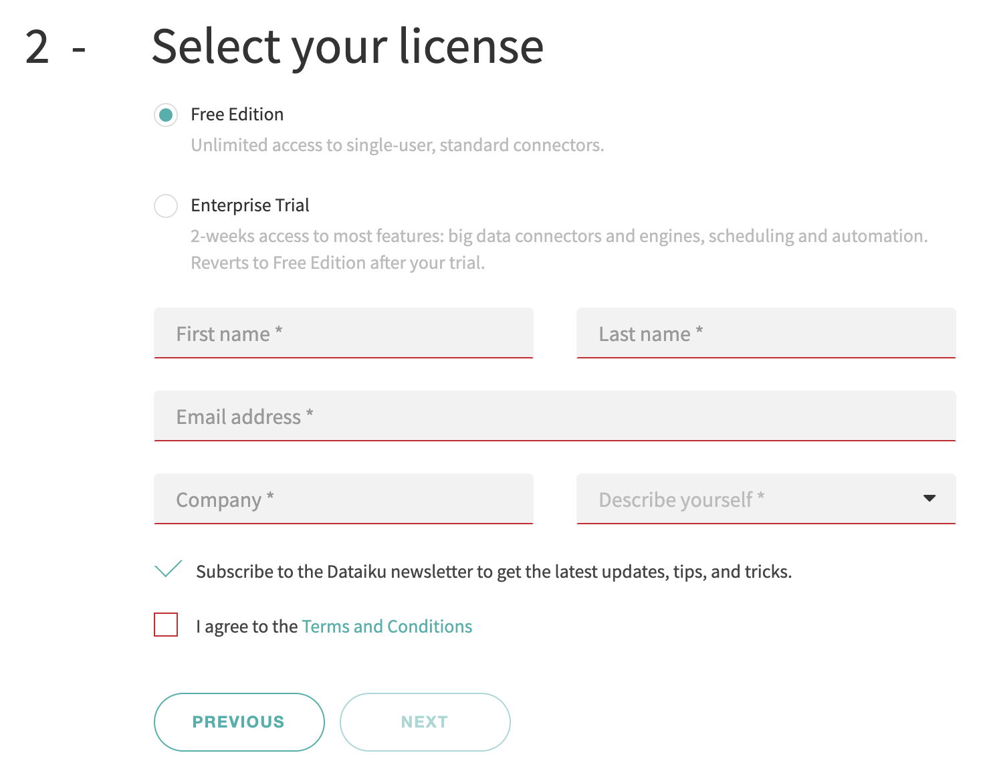

Then you will have your new login and password

It will be admin for both username and password, unless otherwise stated.

Remember this new log in and password and use it to log in and get started!

Note that only Chrome and Firefox are supported.

For additional information, technical details, how-to, or any issue, please see:

* [Google Cloud installation](https://doc.dataiku.com/dss/latest/installation/other/gcp.html) documentation
* [Community answers](https://answers.dataiku.com/)

When you see this page, it means you have created your account and opened it successfully.

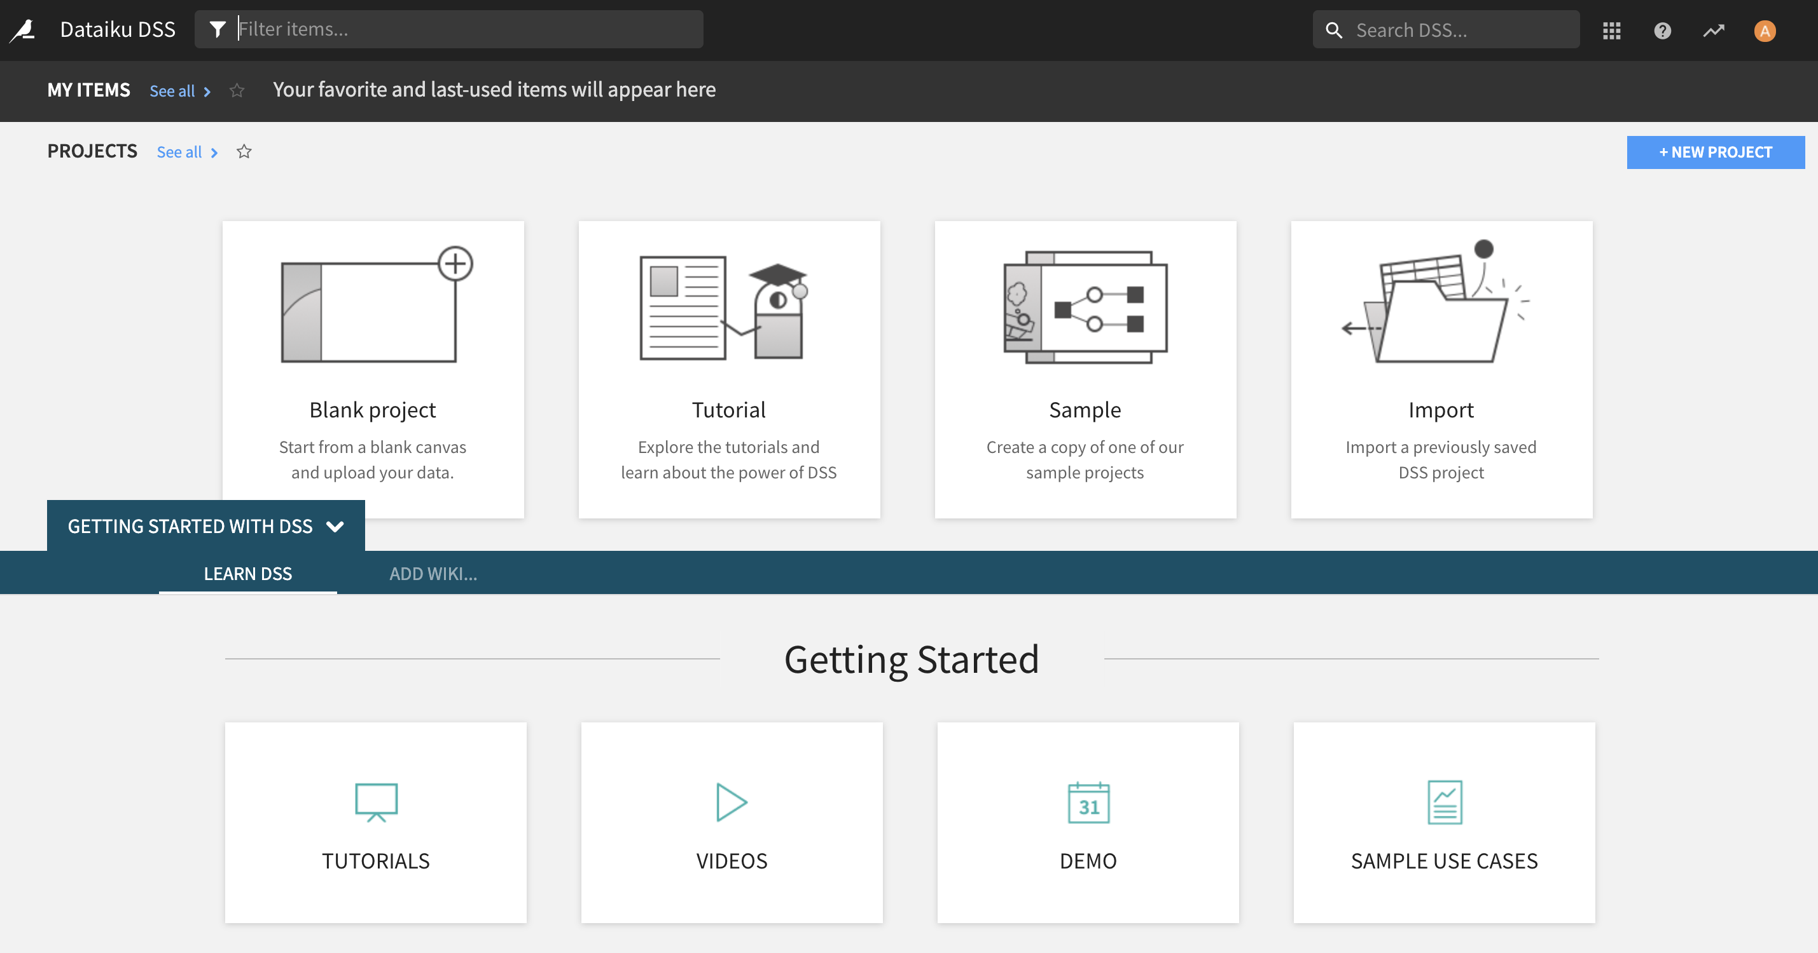

## Logging out of Google Cloud’s DataIku

When you are done, remember to log out.

You also need to shut off the instance in your Google Cloud Console. To do so, open the 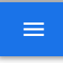 on Google Cloud and scroll down to Compute Engine, and select VM Instances

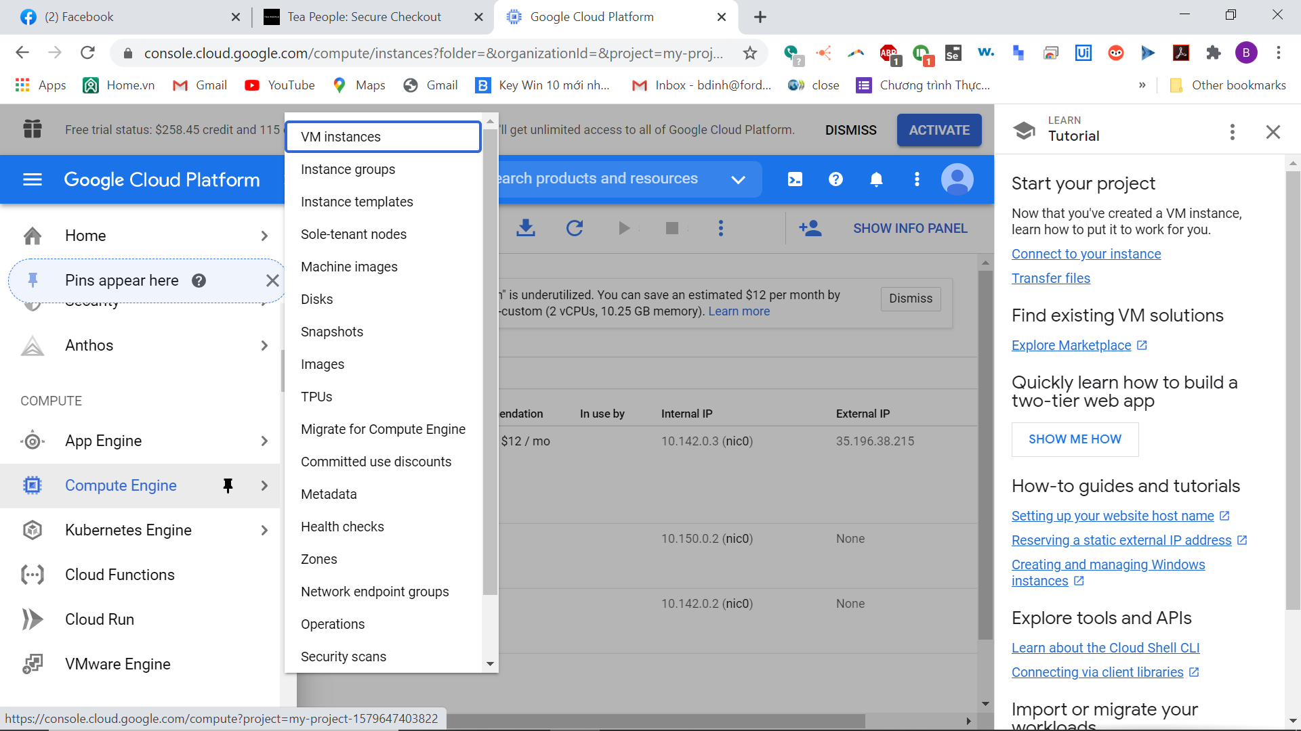

You will see DataIku there, click the three dots next to dataiku vm instance and select **Stop**

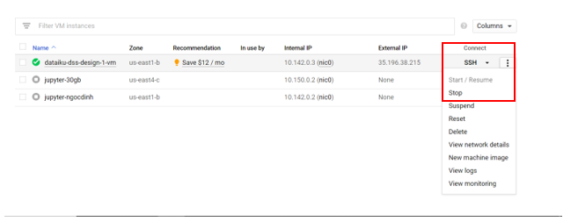

## Logging onto DataIku after initial launch

After successfully deploying DataIku on your computer, to launch DataIku again, open the  on Google Cloud and scroll down to **Compute Engine**, and select **VM Instances**



Click on the three dots next to the DataIku instance and select Start/Resume. I already have mine started in this screenshot so it is greyed out.

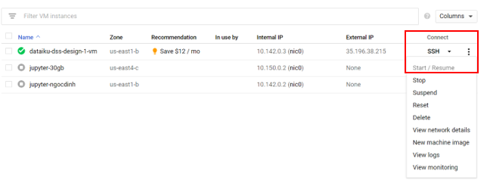

Then after the DataIku instance has been started successfully, it should have a green checkmark next to the instance.

The table also shows the external IP of the instance. Copy the External IP and open it in another tab.

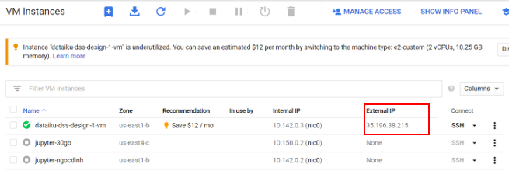

**Part 2- Introduction to Visual Recipe and Prepare**

In this tutorial, we will work on data preparation (Prepare) in the visualization recipe. The data set used is the order dataset. On the data set exploration page, there is an "action" drop-down button in the upper right corner. This "action" contains all the operations that can be performed on the current data set, which mainly includes:

* **Details** (basic information of the data set, such as creator, creation time, description, label, size, etc.)
* **Timeline** (operation history of the data set)
* **Actions** (operations that can be performed on the data set, including basic operations such as exploration, labeling, and export, Lab, visualization Recipe, code Recipe, Plugin Recipe, Other Recipe such as prediction, clustering, etc., Other Actions)

# First Steps

Create a new project.

Click **New project** 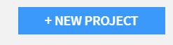

Select **Blank Project**

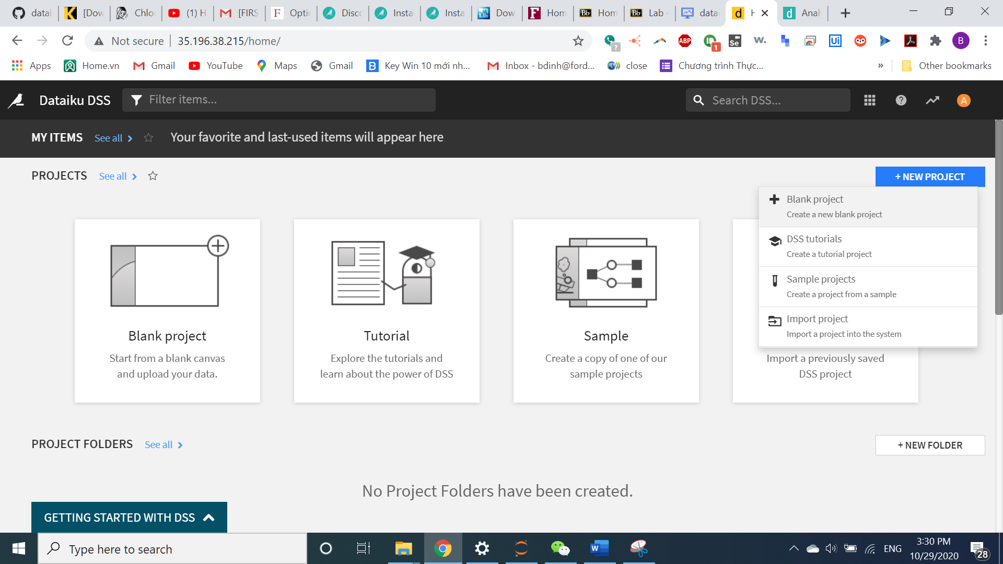

Give a name, and click **Create**

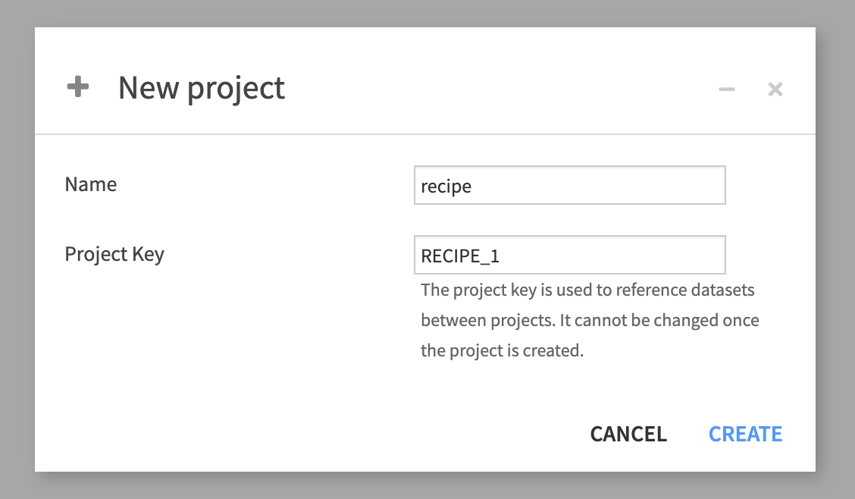

On this page, Click on DATASETS

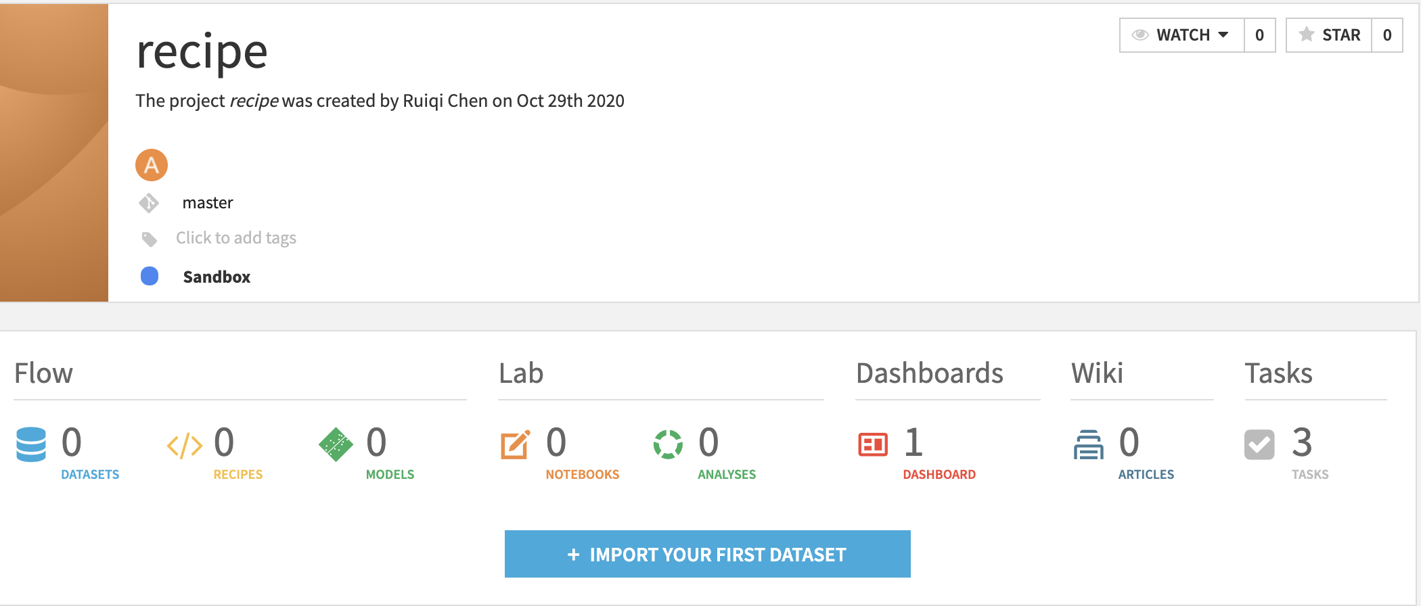

Import the **orders.csv** file provided on BB by clicking on **IMPORT YOUR FIRST DATASET**

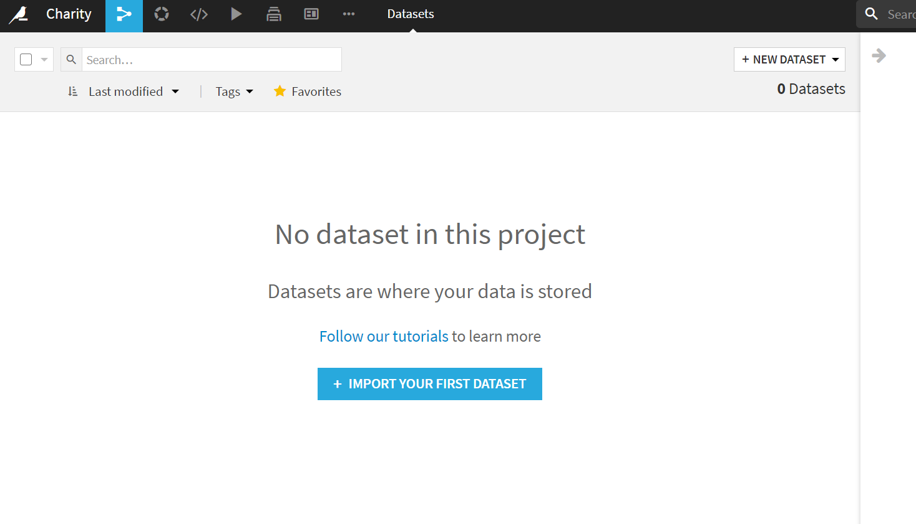

Click on **Upload your files**

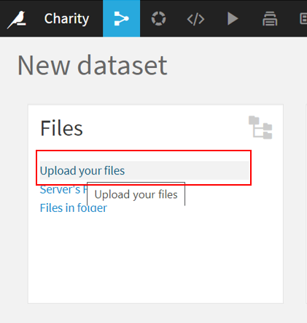

Drag the file into the space and wait for it to upload

Scroll down and click **Preview**

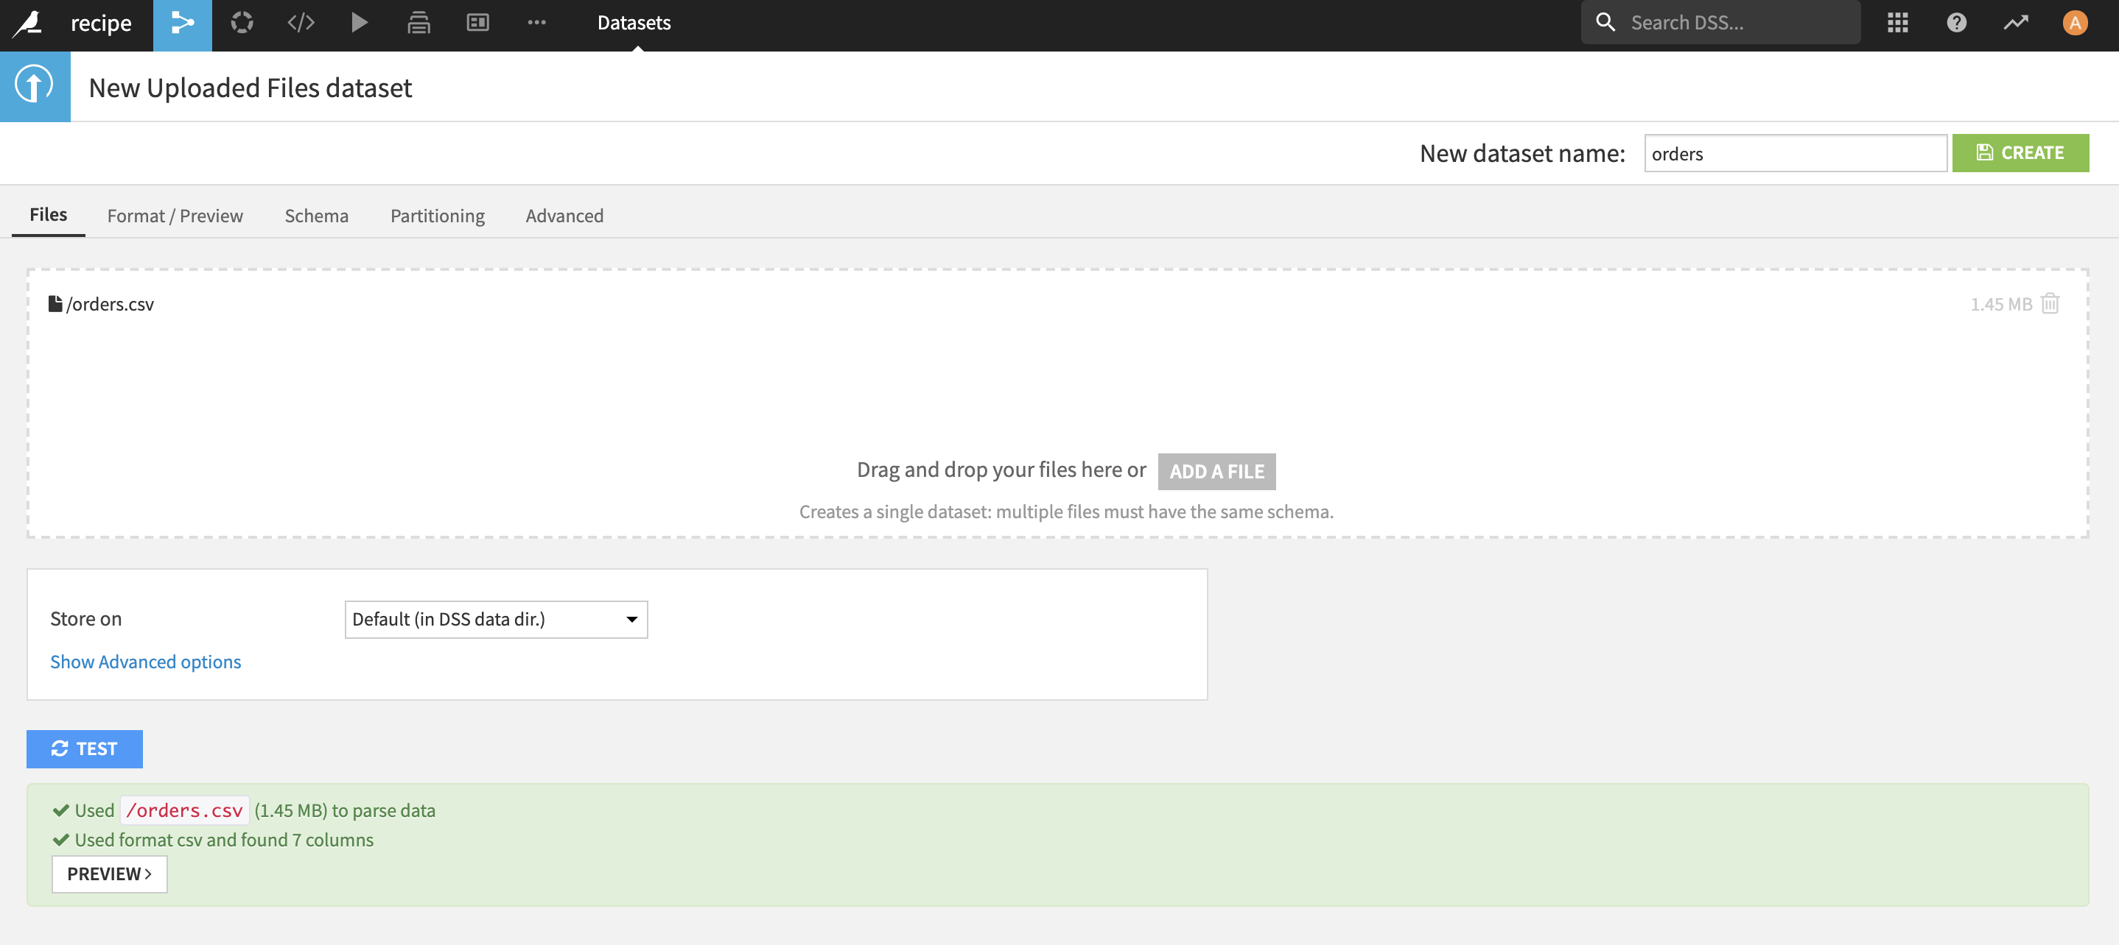

Click **CREATE. You will have a table as follows:**

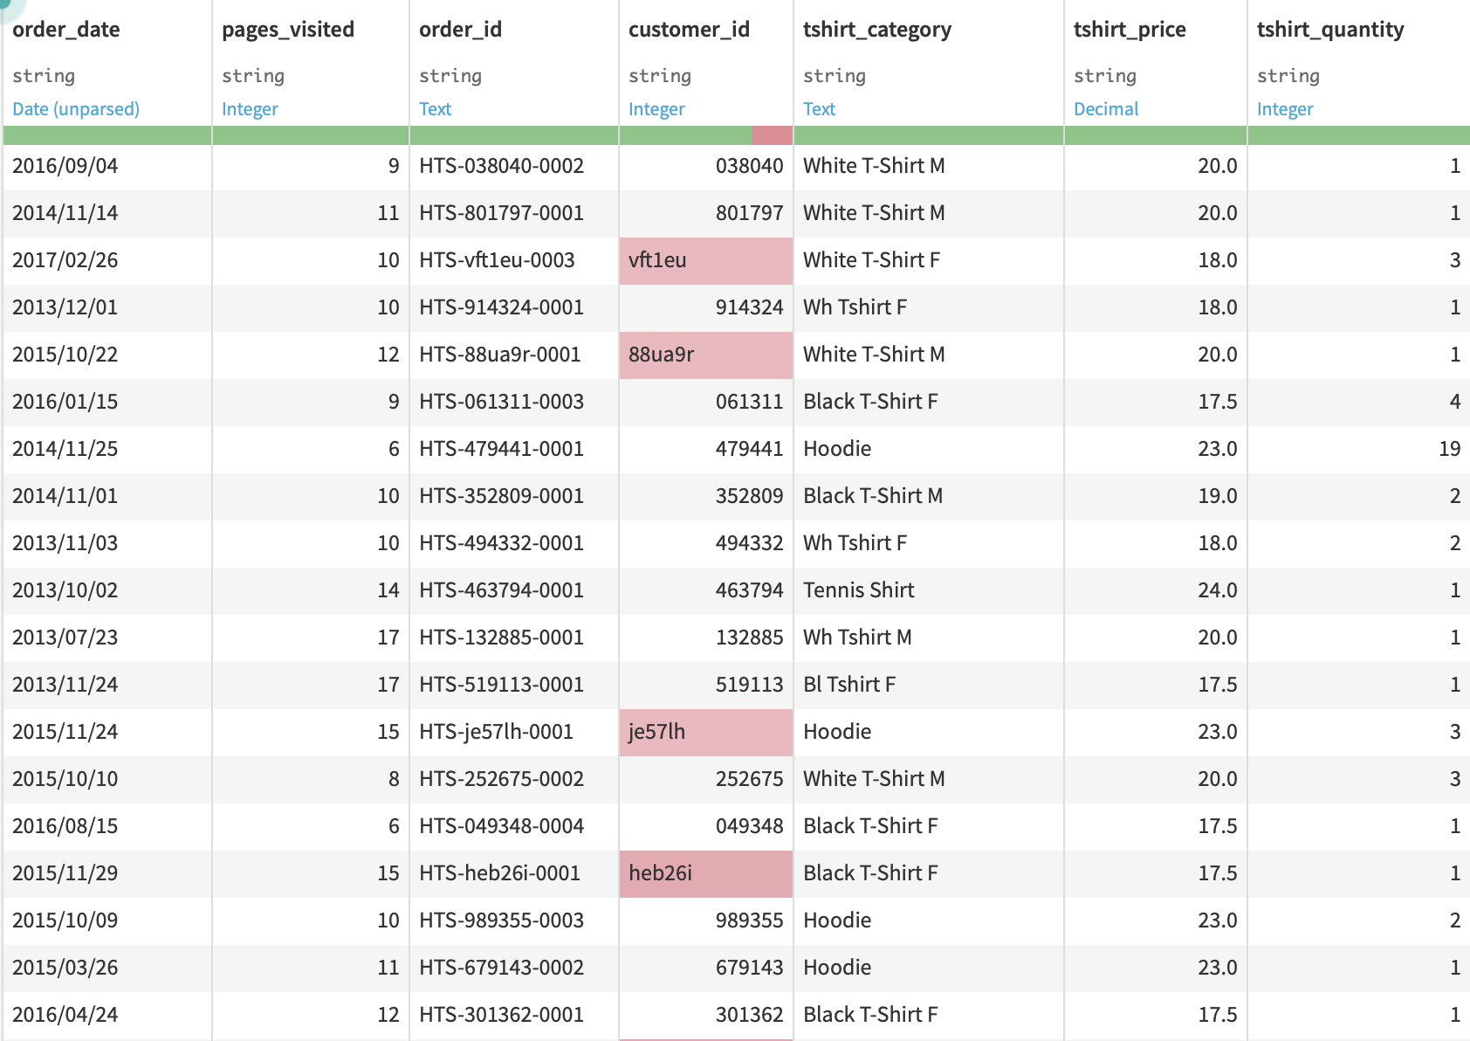

Click **Prepare** to create a new dataset.

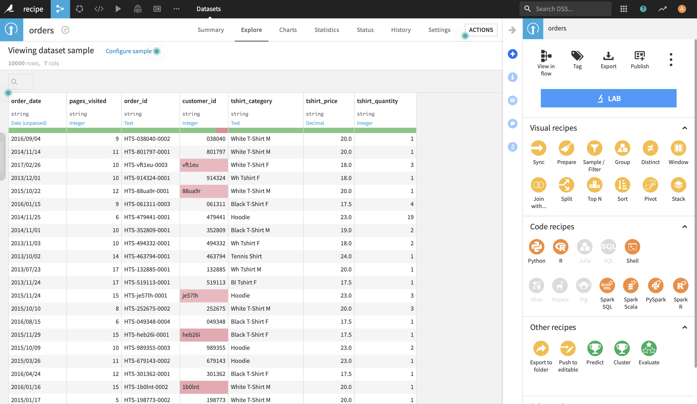

Use the dataset name + **_Prepared** as the output dataset to create a new dataset.

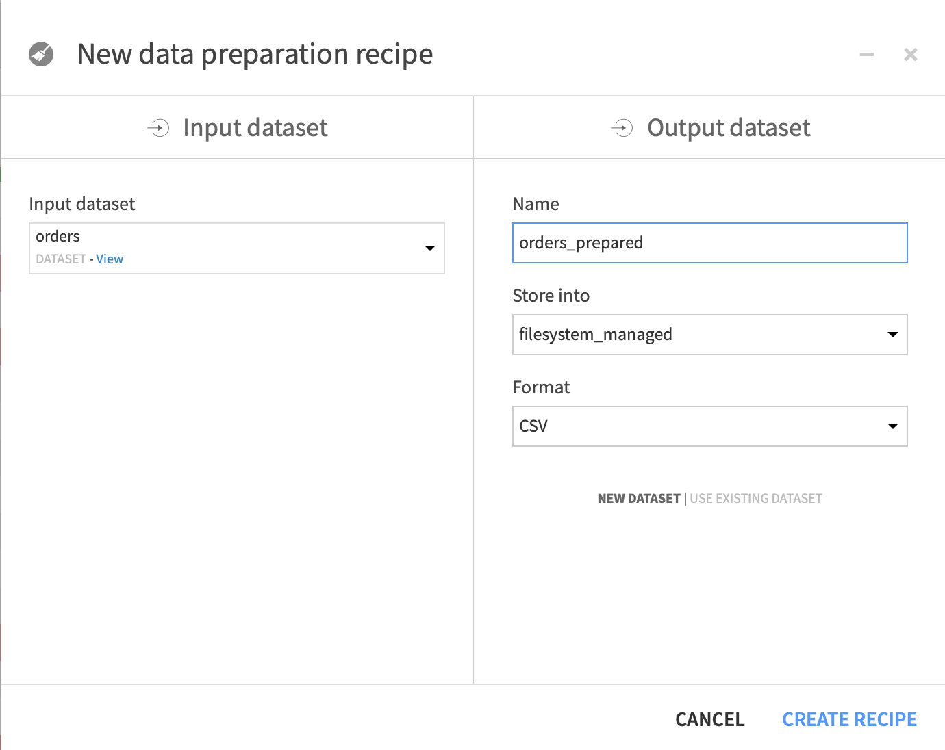

There are two ways to Replace **Wh Tshirt M** with **White T-Shirt M** in the tshirt_category field (because White T-Shirt M and Wh Tshirt M are actually the same type).

The first way is to click **Add New Step** in the Script.

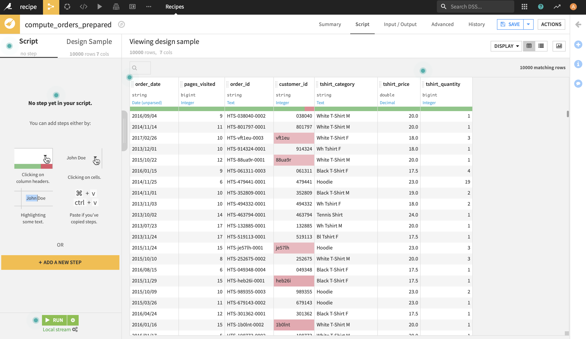

Select **Find and Replace** from the processors library below

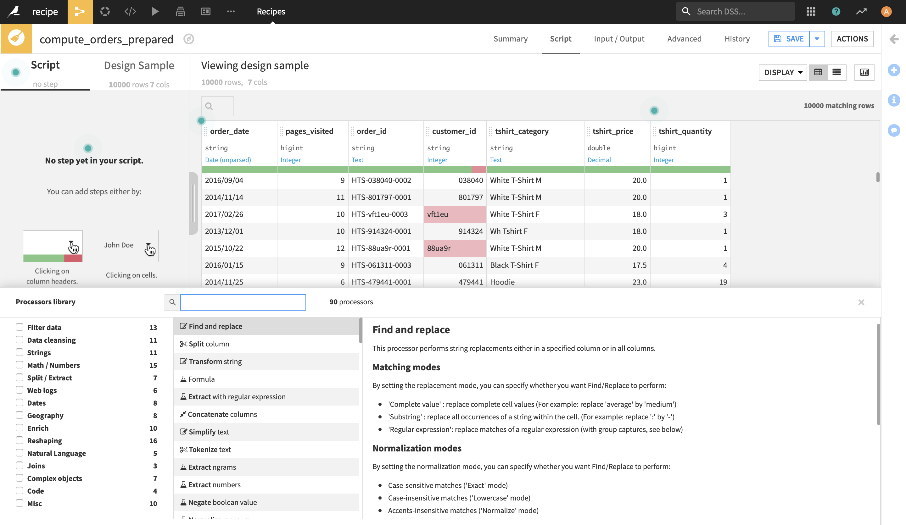

Add a Replace step to the Script on the left, enter **tshirt_category** in the column, and replace **Wh Tshirt M** with **White T-Shirt M**, and click the **ok** button. The results will appear on the right: the background color of the replaced cell will be displayed in light blue

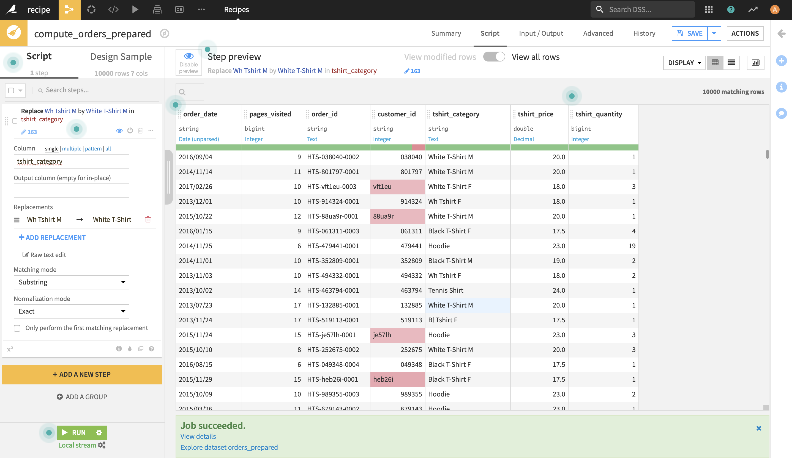

Another way is to click the drop-down button to the right of the **tshirt_category** column and select **Analyze**

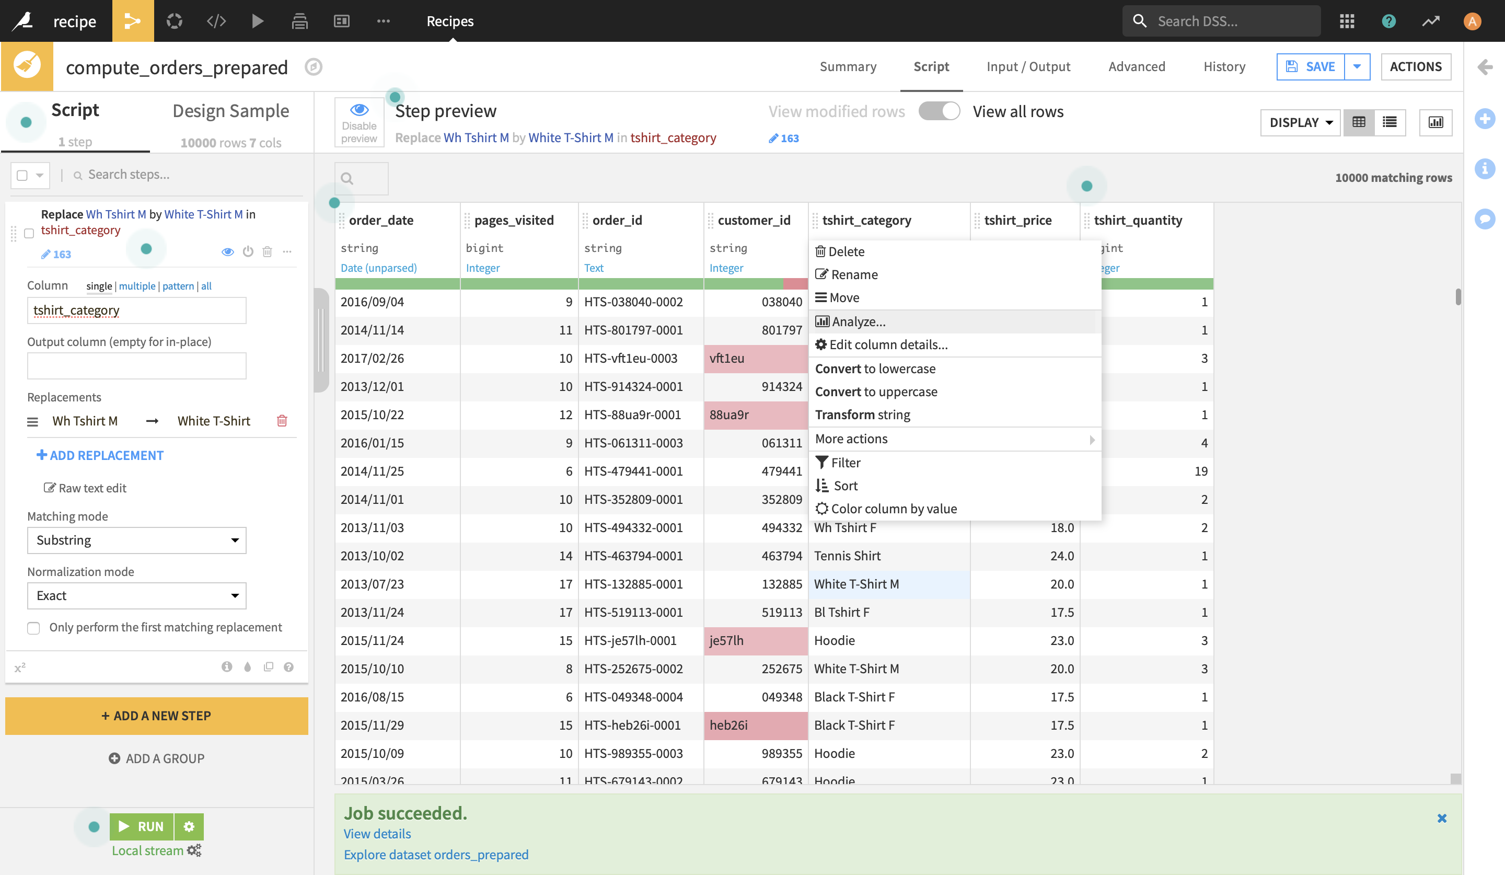

Select **White T-Shirt M** and **Wh Tshirt M**, and then choose **Merge Selected** in MASS Action. Repeat this process for other categories as needed.

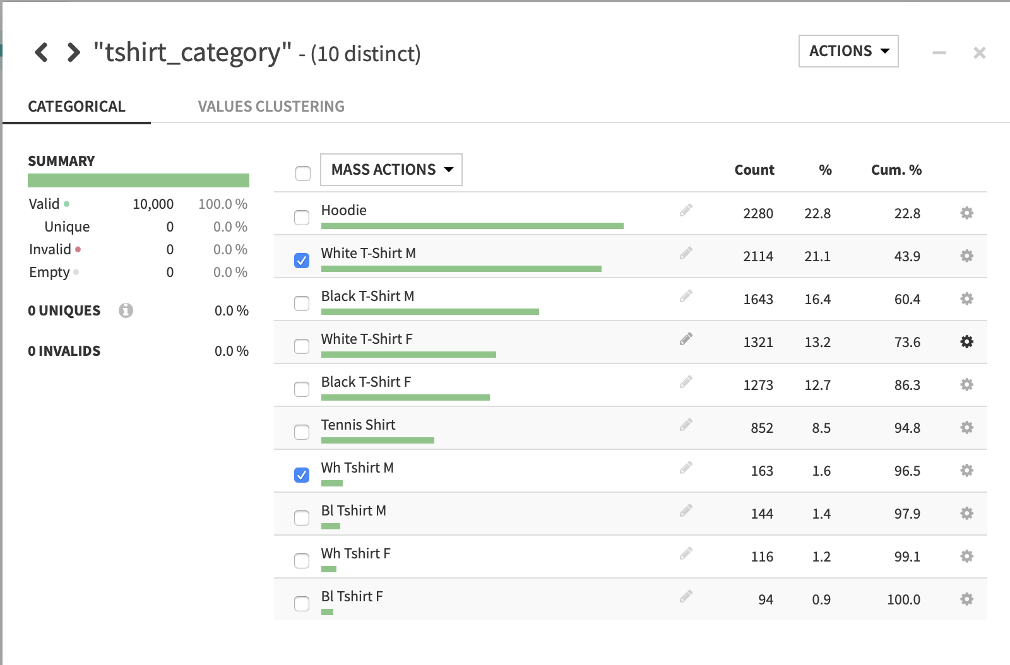

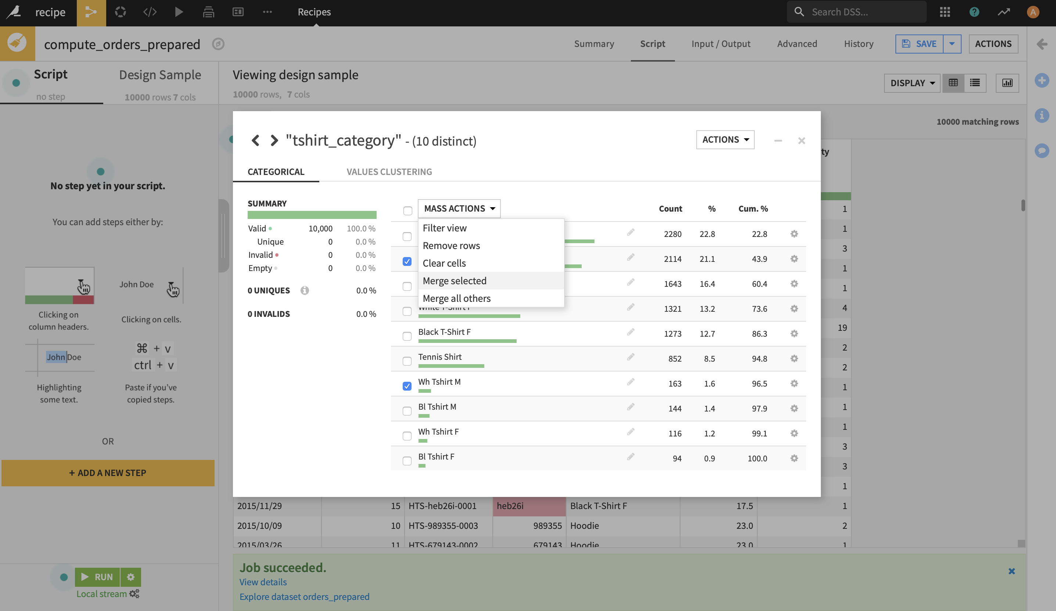

Continue merging until you have the following:

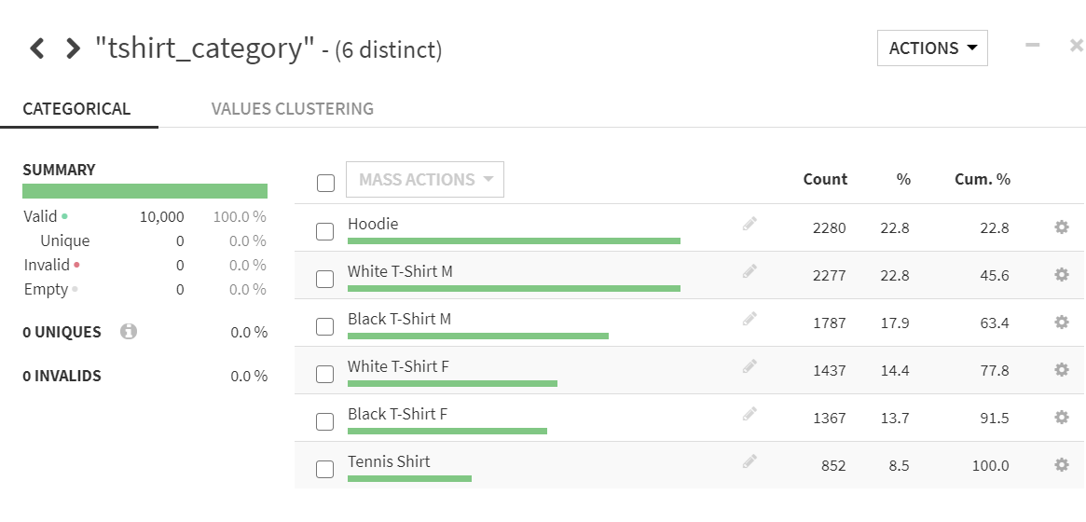

Close the Analyze dialog and see that a “Replace” step has been added to the Prepare Script. You just added the first step to your script.

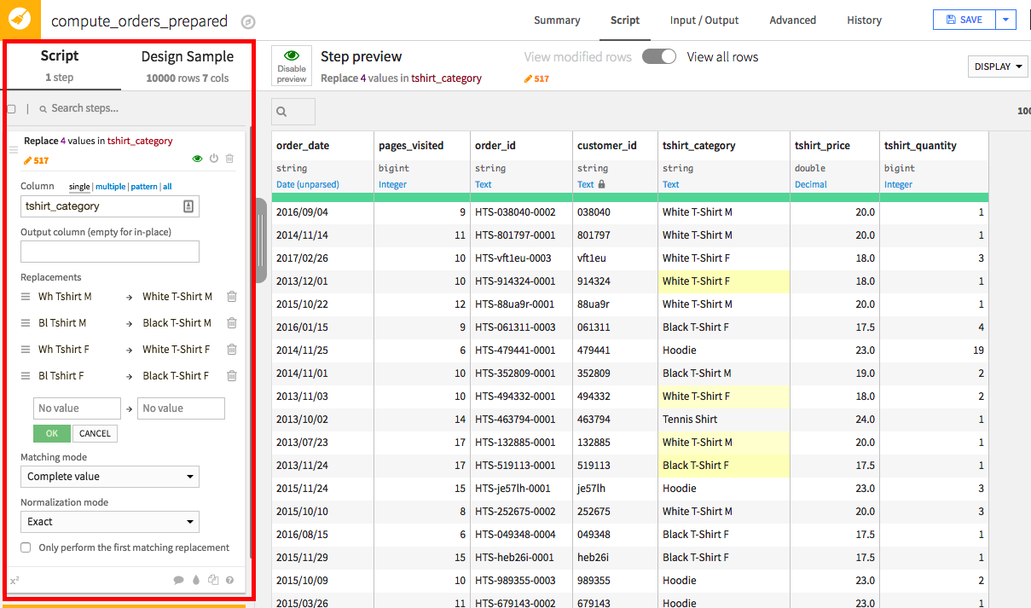

# More Preparation

Now, let’s deal with the order_date. Input dates are unparsed and need to be processed (“parsed”) if we want to use them. Dates are notoriously difficult to work with, but DSS makes it very easy.

Open the column dropdown and select **Parse date**.

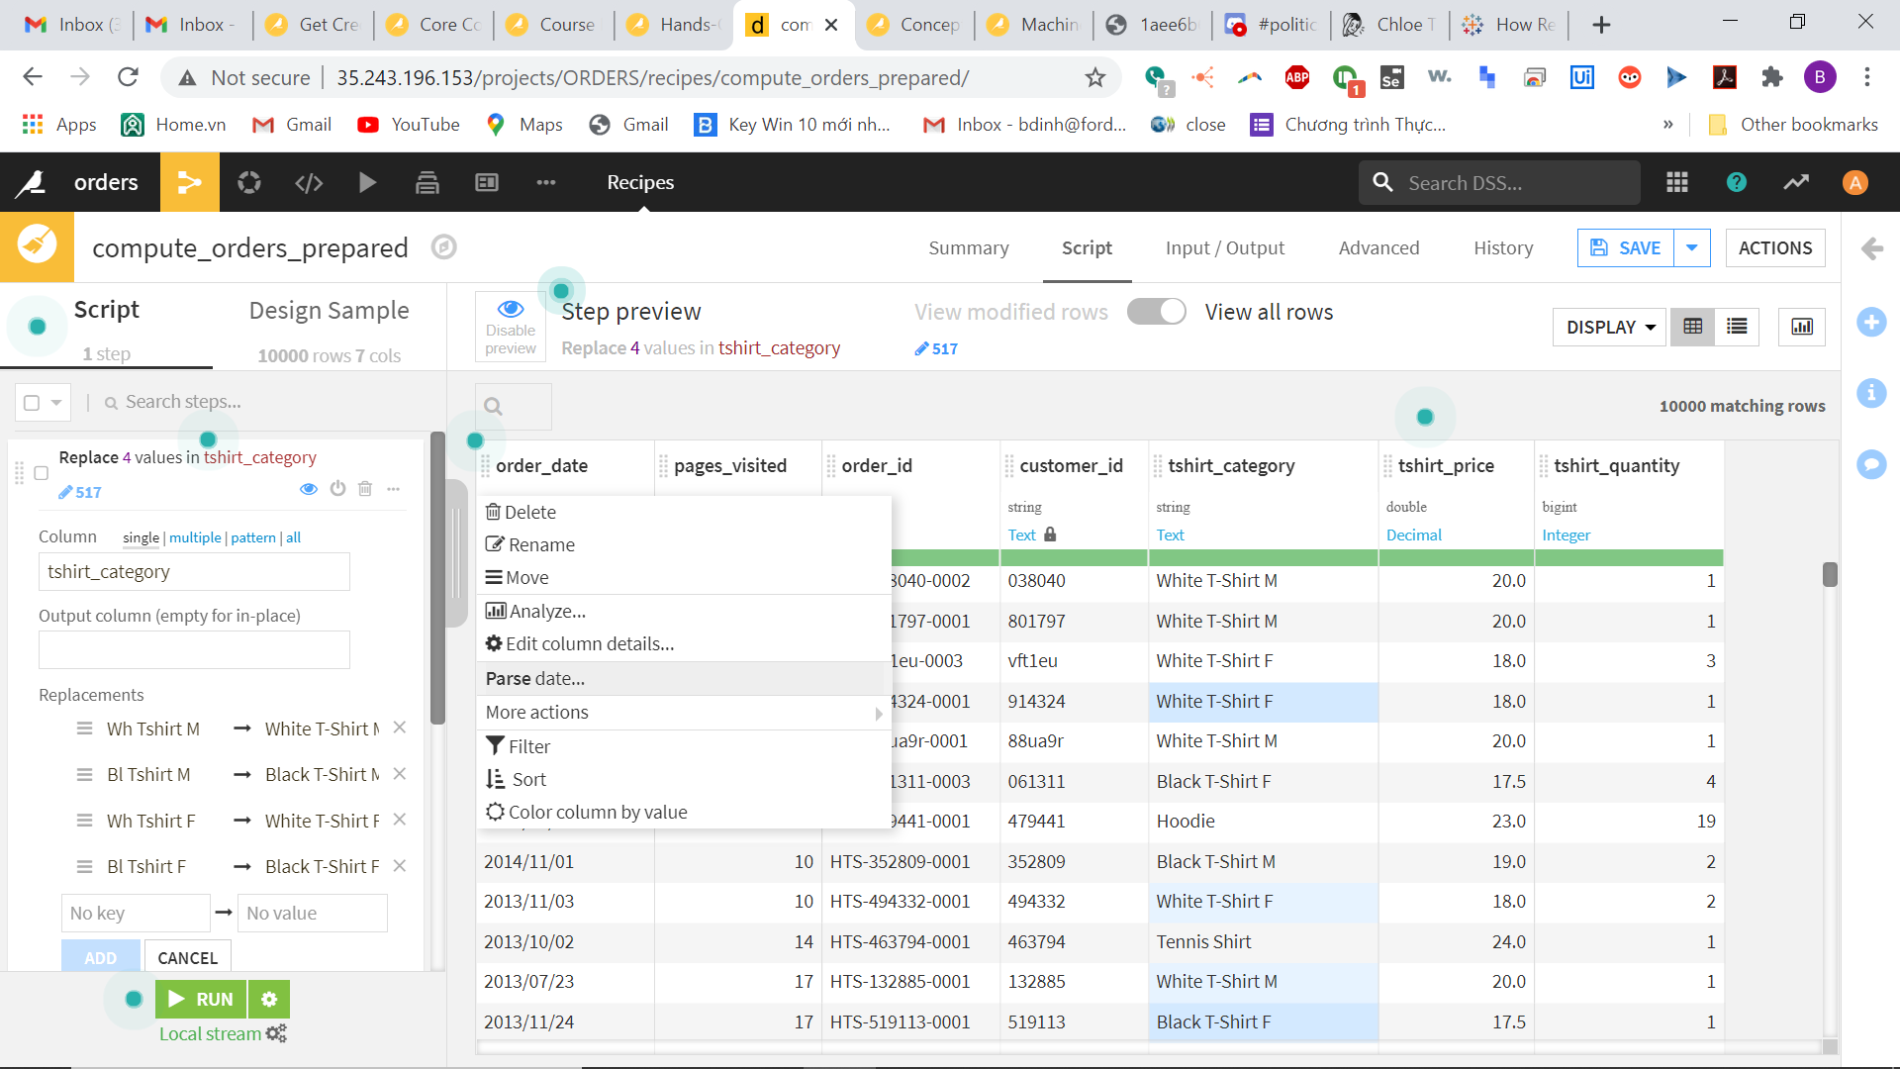

The **Smart Date** dialog opens and shows you the most likely formats for your dates and how the dates would look like once parsed, with some sample values from the dataset. In our case, the dates appear to be in yyyy/MM/dd format. Select this format, click **OK** and see that a “Parse date” step has been added to the Prepare Script.

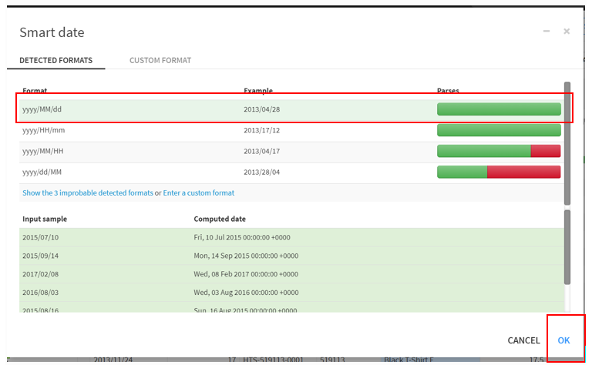

By default, “Parse date” creates a new column order_date_parsed. Since we’d rather want the parsed date to stay in the order_date column, let’s clear the “Output column” text box in the script step, which has the effect of parsing dates in place.

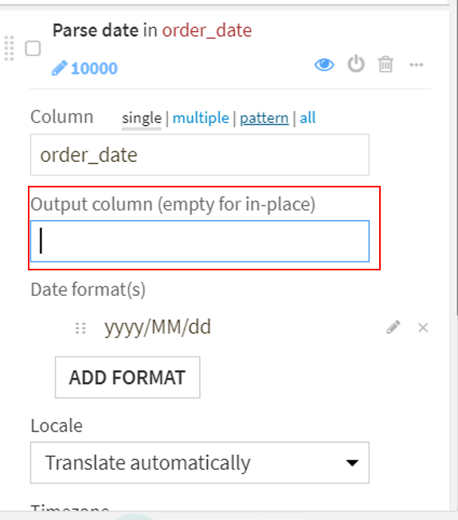

Finally, let us compute the value of each order. The orders dataset includes the number of t-shirts in each order and the price per t-shirt, but we need to compute the total of each order so that we can analyze the value of each order. We are going to use a **Formula** step for this. DSS formulas are a very powerful expression language to perform calculations, manipulate strings, and much more.

This time, we will not add the step by clicking on a column header, but instead use the **processors library** which references all 80+ data preparation processors:

* Click the yellow **+Add a New Step** button in the left bar

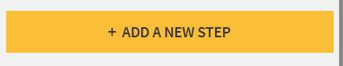

* Select **Formula** (you can search for it)

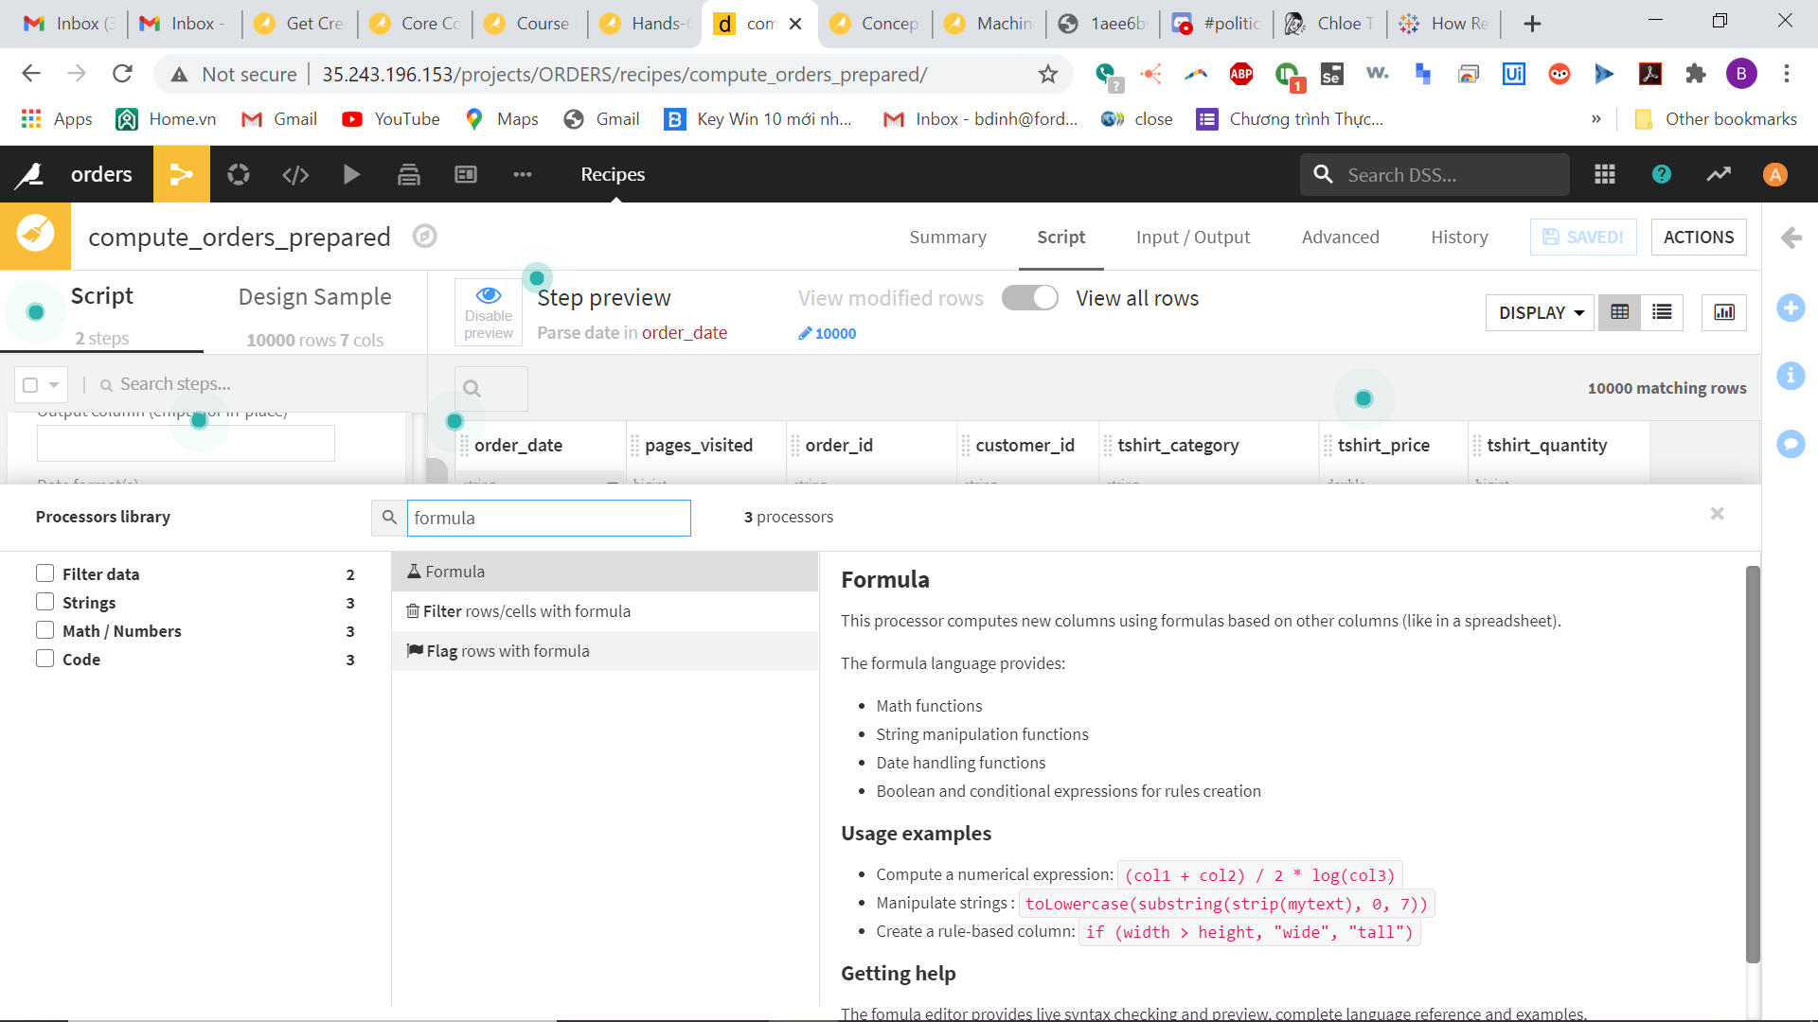

* Type total as the name of the new column.
* In the expression, type tshirt_price * tshirt_quantity (you can also click **Edit** to bring up the advanced formula editor, which will autocomplete column names)

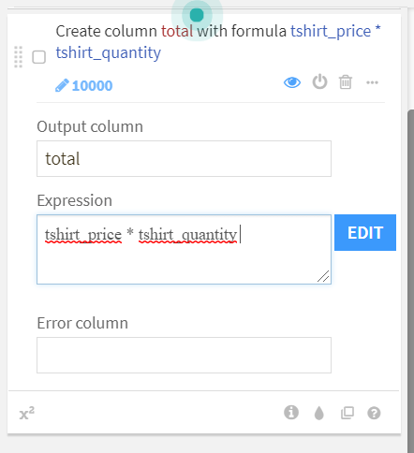

* Click anywhere and see the new total column appear

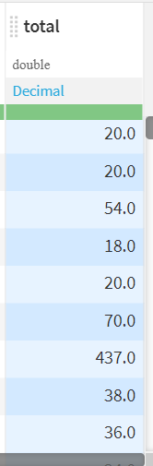

We no longer need the price and quantity, so we can delete those columns.

* Click on the column header.
* Choose **Delete**

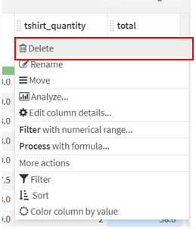 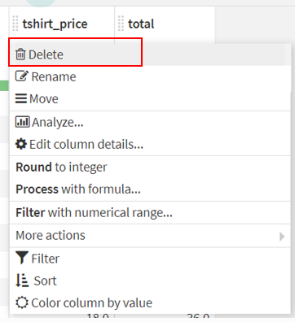

Click the **Run** button in the Script to build the output data set.

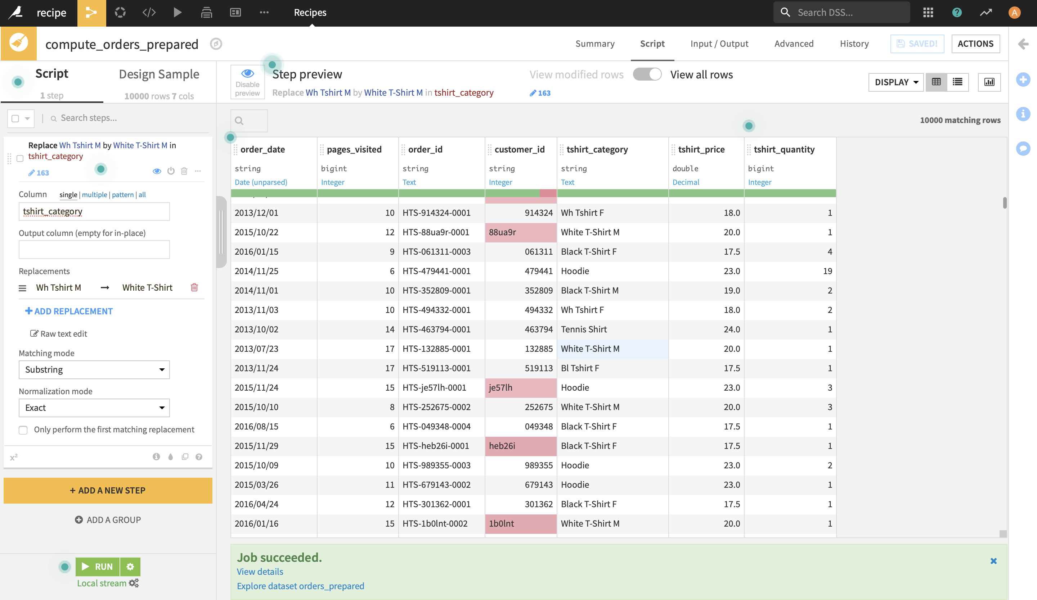

You will also be asked to update the **schema. Click on Update Schema**

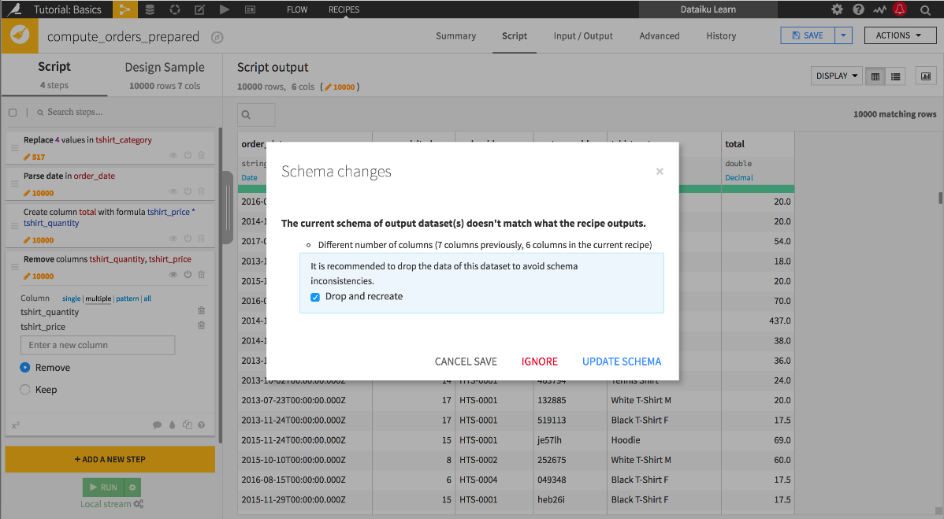

Click **Explore dataset** **orders_prepared** to enter the exploration page of the output dataset.



# Interactive Statistics

You can also use the **Statistics** page of the dataset to perform exploratory data analysis (EDA). The Statistics page allows you to generate statistical reports on your data by creating **Worksheets** and **Cards**.

* Click on the **Statistics** tab, and click **+Create Your First Worksheet**. 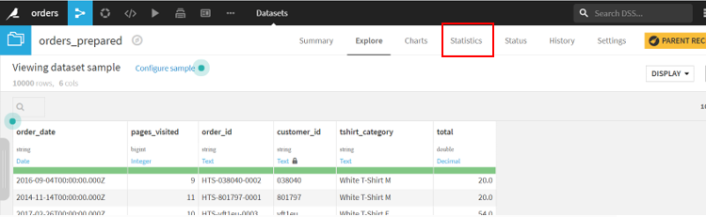
* Select the **Univariate analysis** box to open the “Univariate analysis” window. 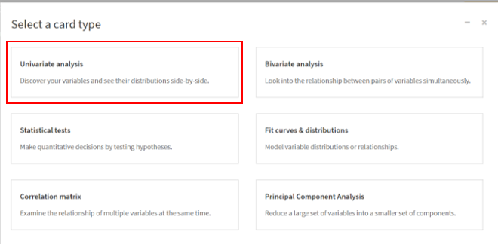
* Select pages_visited, tshirt_category, and total from the first column of the window, and click the “plus” button next to “Variables to describe”. Click **Create Card**.

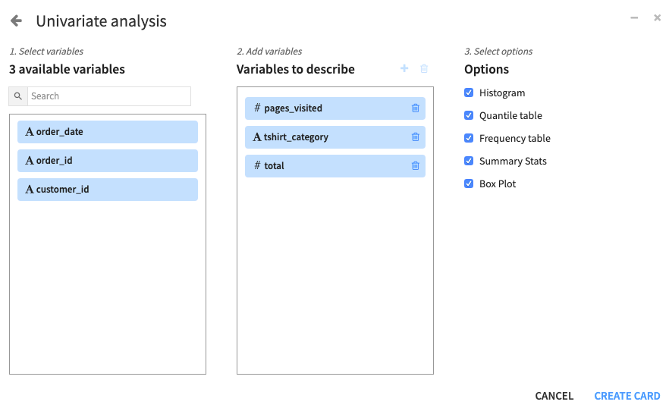

DSS automatically selects the statistical “Options” (in the third column of the window) that are appropriate for the numerical variables (pages_visited and total) and the categorical variable (tshirt_category). You can deselect any of these options if you so choose.

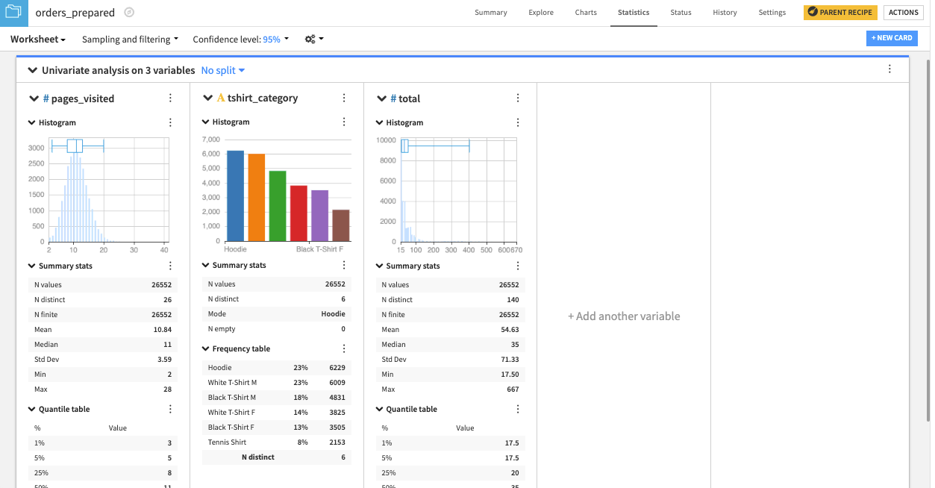

DSS creates a card with one section for each variable. The type of statistical chart and descriptive statistic in each section depends on whether the variable is categorical or numerical. For example, tshirt_category, a categorical variable, has a bar chart (or categorical histogram), while pages_visited and total each have a numerical histogram and box plot insert. Also, the quantile table is applicable to the numerical variables, while the frequency table is applicable to the categorical variable.

Note: By default, DSS computes worksheet statistics on a sample of the first records in your dataset. You can configure this setting by clicking the drop-down arrow next to **Sampling and filtering**. We won’t change it in this example.

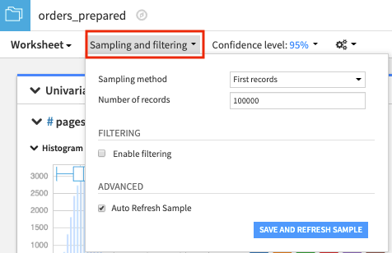

We may also be interested in checking whether the total variable follows an exponential distribution. The interactive statistics feature allows you to estimate the parameters of univariate probability distributions using the **Fit Distribution** card.

* Click the **+New Card** button from the “Worksheet” window 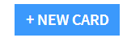
* select **Fit curves & distributions**.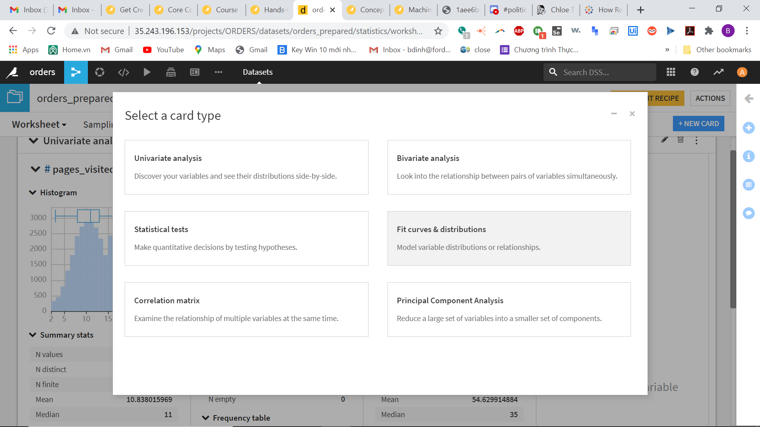
* Select the **Fit Distribution** card.

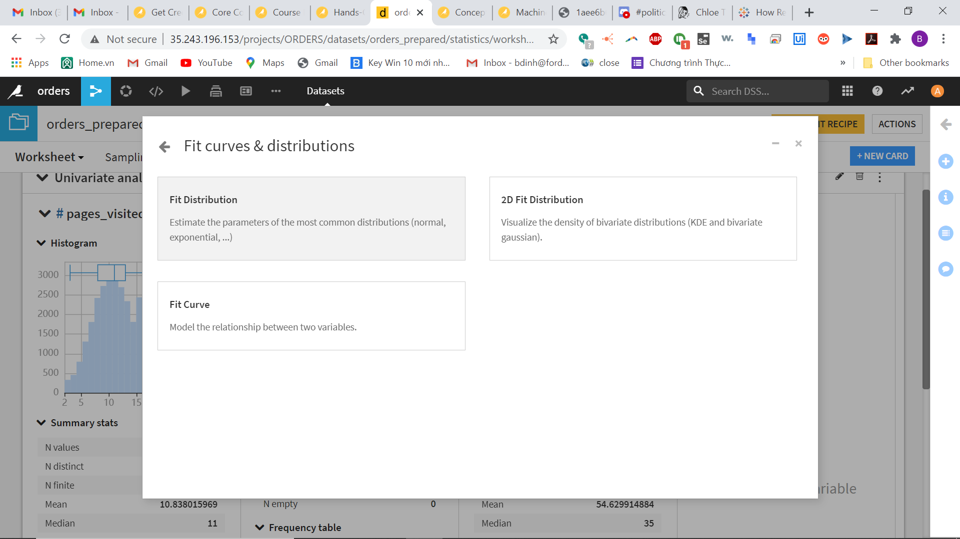

* Select **total** as the “Variable” and **Exponential** as the “Distribution”.

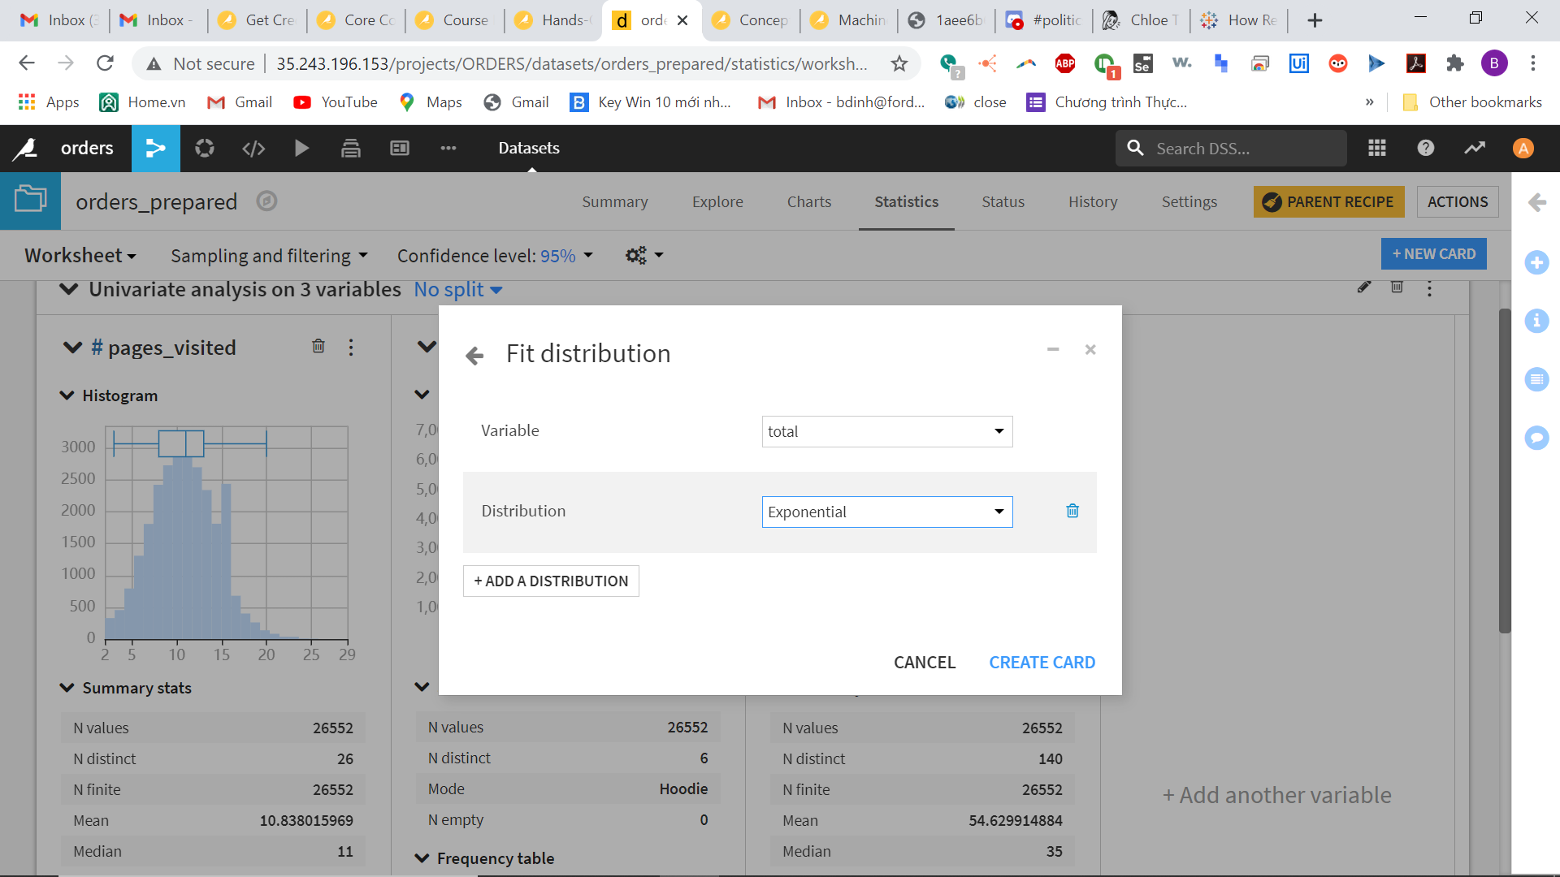

* Click **Create Card** and scroll down.

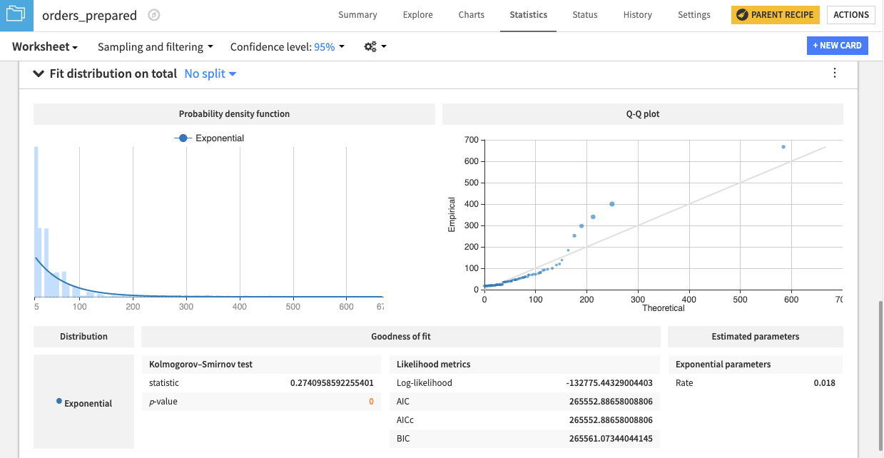

DSS creates a card that shows the exponential distribution fit to the data. There is also a Q-Q plot that compares the quantiles of the data against the quantiles of the fitted distribution. Observing points far from the identity line suggests that the data could not have been drawn from the exponential distribution.